**Control Interface:**

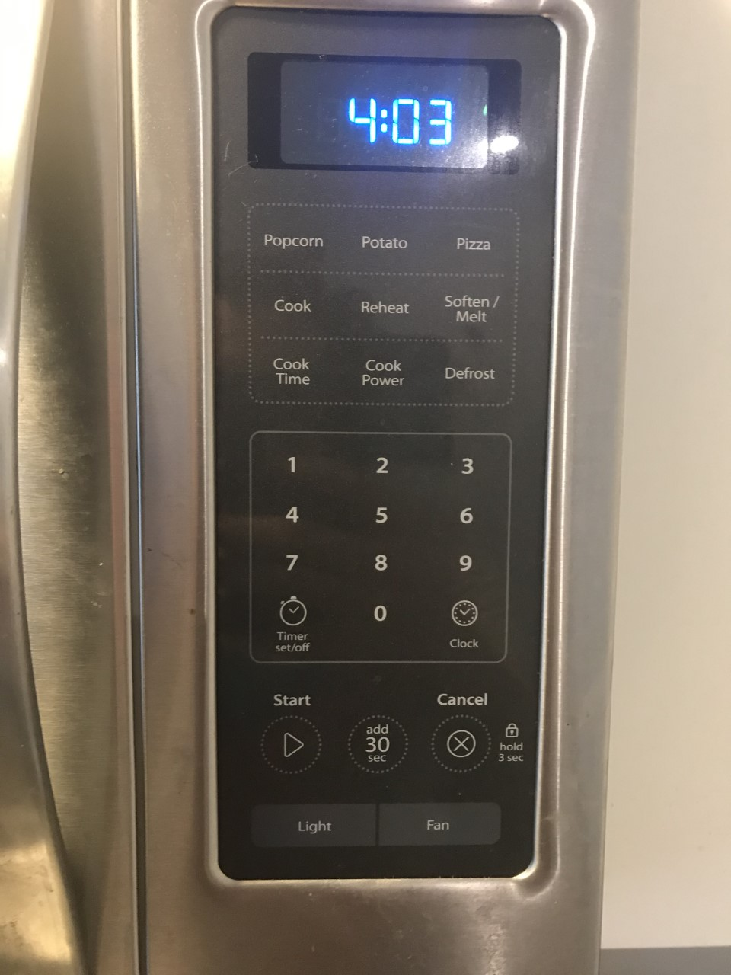

**Interface in operation:**

**Issues:**

1. The main design of this microwave doesn’t imply anything when it comes to how to actually enter in anything. This is bad because there should at least be something intuitive to make sure people know where to begin.
2. There is a cook button which is redundant since the main point of a microwave is to cook.
3. Cook time is an unneeded button and could be replaced with a instruction addition.
4. The 3 food options of popcorn, potato, and pizza which is kind of lacking and could be replaced with a single food button with the types of food behind the button.

**Common Uses:**

1. Cook food like hot dogs and popcorn that are not cooked previously.
2. Reheat food to eat.

The microwave has 2 buttons for reheating and cooking which does help when it comes to these features.

**Rare Uses:**

1. Bring water to a boil.
2. Defrost food.

**Common Sequence of Actions:**

1. Put food in the microwave.
2. Click the time you want to cook.
3. Click the start button.

**Support:**

The microwave does have self-explanatory buttons that the user can click on, like cook and reheat.

**Feedback:**

The only feedback the microwave provides to the user is the time and a tiny symbol that symbolizes the mode it is in. The symbol is something the user must guess since its not on the buttons.

**Improvements:**

The major improvement I want to implement is to actually show clearly the user what mode they are currently in at all times during the cooking, so my design is as follows.

**Design:**

**Explanation:**

So, I have made my design with the original numpad and timer interface as I thought it was well established, but I have added cook time as a label instead of a button. I then added two boxes with arrow keys labeled mode and food as to allow the user to specifically choose what they want to do to their type of food.